### Pointers in C++

A pointer is a data type which holds the address of other data type. The “**&**” operator is called “**address off**" operator, and the **"*”** operator is called “**value at**” dereference operator.

“**&**” ----🡪 **address off** operator

**"*”----🡪 value at** dereference operator

An example program for pointers is shown in figure 1.

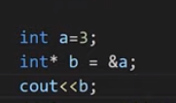

***Figure 1: Pointer Program***

As shown in figure 1, at 1st line an integer variable “**a**” is initialized with the value “**3**". At the 2nd line, the address of integer variable "**a**” is assigned to the integer pointer variable “**b**". At the 3rd line, the address of the integer pointer variable "**b**” is printed. The output of the following program is shown in figure 2.



***Figure 2: Pointer Program Output***

As shown in figure 2, the address of the integer pointer variable "**b**” is printed. The main thing to note here is that the address printed by the variable “**b**" is the address of integer variable "**a**” because we had assigned the address of variable “**a**” to the integer pointer variable “**b**". To clarify, we will print both variable "a" and variable "b" addresses, which are shown in figure 3.

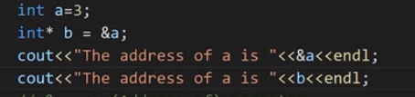

***Figure 3: Pointer Program Example 2***

As shown in figure 3, now we printed both variable “**a**” and variable “**b**” addresses. The output for the following program is shown in figure 4.



***Figure 4: Pointer Program Example 2 Output***

As shown in figure 4, both variables "**a**” and “**b**” have the same addresses, but in actual, this is the address of the variable "**a**”, the variable “**b**" is just pointing to the address of the variable "**a**”.

To see the value of variable “**a**" using a pointer variable, we can use the "**\***" dereference operator. An example of the dereference operator program is shown in figure 5.

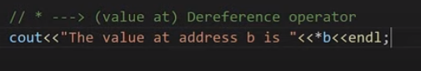

***Figure 5: Dereference Operator example***

As shown in figure 5, the value at address “**b**” is printed. The main thing to note here is that the value printed by the pointer variable “**b**” will be the value of variable “**a**” because the pointer variable “**b**" is pointing to the address of the variable "**a**”. The output for the following program is shown in figure 6.



***Figure 6: Dereference Operator Example***

#### Pointer to Pointer

Pointer to Pointer is a simple concept, in which we store the address of one Pointer to another pointer. An example program for Pointer to Pointer is shown in figure 7.

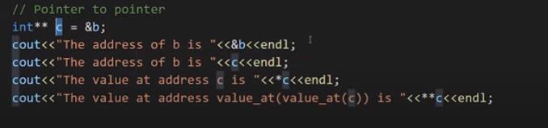

***Figure 7: Pointer to Pointer Example Program***

As shown in figure 7, at the 1st line, the address of the pointer variable "**b**” is assigned to the pointer variable “**c**”. At 2nd line, the address of the pointer variable "**b**” is printed. At the 3rd line, the address of the pointer variable "**c**” is printed. At line 4th, the value at the pointer variable "**c**” is printed. At line 5th, the pointer variable "**c**” will be dereferenced two times, and it will print the value at pointer variable "**b**”. The output of the following program is shown in figure 2. The output for the following program is shown in figure 8.

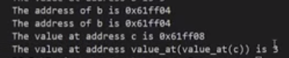

***Figure 8: Pointer to Pointer Example Program Output***